**PIZZA SALES DASHBOARD**

**PROBLEM STATEMENT**

**KPI’s REQUIREMENT**

**We need to analyze key indicators for our pizza sales data to gain insights into our business performance. Specifically, we want to calculate the following metrics:**

1. **Total Revenue:** The sum of the total price of all pizza orders.
2. **Average Order Value:** The average amount spent per order, calculated by dividing the total revenue by the total number of orders.
3. **Total Pizzas Sold:** The sum of the quantities of all pizzas sold.
4. **Total Orders:** The total number of orders placed.
5. **Average Pizzas Per Order:** The average number of pizzas sold per order, calculated by dividing the total number of pizzas sold by the total number of orders.

**CHARTS REQUIREMENT**

We would like to visualize various aspects of our pizza sales data to gain insight into and understand key trends. We have identified the following requirements for creating charts:

1. **Hourly Trend for Total Pizzas Sold:**

Create a stacked bar chart that displays the hourly trend of total orders over a specific time period. This chart will help us identify any patterns or fluctuations in order volumes on a hourly basis.

**2.Weekly Trend for Total Orders:**

Create a line chart that illustrates the weekly trend of total orders throughout the year. This chart will allow us to identify peak weeks or periods of high order activity.

**3.Percentage of Sales by Pizza Category:**

Create a pie chart that shows the distribution of sales across different pizza categories. This chart will provide insights into the popularity of various pizza categories and their contribution to overall sales.

**4.Percentage of Sales by Pizza Size:**

Generate a pie chart that represents the percentage of sales attributed to different pizza sizes. This chart will help us understand customer preferences for pizza sizes and their impact on sales.

**5.Total Pizzas Sold by Pizza Category:**

Create a funnel chart that presents the total number of pizzas sold for each pizza category. This chart will allow us to compare the sales performance of different pizza categories.

**6.Top 5 Best Sellers by Revenue, Total Quantity and Total Orders**

Create a bar chart highlighting the top 5 best-selling pizzas based on the Revenue, Total Quantity, Total Orders. This chart will help us identify the most popular pizza options.

**7. Bottom 5 Best Sellers by Revenue, Total Quantity and Total Orders**

Create a bar chart showcasing the bottom 5 worst-selling pizzas based on the Revenue, Total Quantity, Total Orders. This chart will enable us to identify underperforming or less popular pizza options.

***1. Total Revenue:***  
SELECT SUM(total_price) AS Total_Revenue from pizza_sales;

A screenshot of a computer

***2. Average Order Value***

SELECT (SUM(total_price) / COUNT(DISTINCT order_id)) AS Avg_order_Value FROM pizza_sales



***3.Total Pizza Sold***

SELECT SUM(quantity) AS Total_pizza_sold FROM pizza_sales



***4.Total Orders***

SELECT COUNT(DISTINCT order_id) AS Total_Orders FROM pizza_sales



*5. Average Pizzas Per Order*

SELECT CAST(CAST(SUM(quantity) AS DECIMAL(10,2)) /

CAST(COUNT(DISTINCT order_id) AS DECIMAL(10,2)) AS DECIMAL(10,2))

AS Avg_Pizzas_per_order

FROM pizza_sales



**Charts Queries**

1. **Hourly Trend for Total Pizzas Sold:**

SELECT DATEPART

(HOUR, order_time) AS order_hours,

SUM(quantity) AS total_pizza_sold

FROM pizza_sales

GROUP BY DATEPART(HOUR, order_time)

ORDER BY order_hours;

1. **Weekly Trend for Total Orders**

SELECT YEAR(order_date) AS year,

DATEPART(ISO_WEEK, order_date) AS WeekNumber,

COUNT(DISTINCT order_id) AS total_orders

FROM pizza_sales

GROUP BY DATEPART(ISO_WEEK, order_date),

YEAR(order_date)

ORDER BY year, WeekNumber;

1. **Percentage of Sales by Pizza Category**

SELECT pizza_category, CAST(SUM(total_price) AS DECIMAL (10,2)) as total_revenue,

CAST(SUM(total_price) * 100 / (SELECT SUM(total_price) from pizza_sales)AS decimal(10,2)) AS PCT

FROM pizza_sales

GROUP BY pizza_category

ORDER BY total_revenue DESC;

1. **% of Sales by Pizza Size**

SELECT pizza_size,

ROUND(SUM(total_price), 2) AS total_revenue,

ROUND(SUM(total_price) * 100 / (SELECT SUM(total_price) FROM pizza_sales), 2) AS pct_total_revenue

FROM pizza_sales

GROUP BY pizza_size

ORDER BY total_revenue DESC;

1. **Total Pizza Sold by Pizza Category**

SELECT

pizza_category,

SUM(quantity) AS total_pizza_sold

FROM pizza_sales

GROUP BY pizza_category

ORDER BY total_pizza_sold DESC;

1. **Top 5 Best Sellers by Revenue**

SELECT TOP 5

pizza_name,

SUM(total_price) AS Total_Revenue

FROM pizza_sales

GROUP BY pizza_name

ORDER BY Total_Revenue DESC

1. **Top 5 Pizza Best Sellers by Total Quantity**

SELECT TOP 5

pizza_name,

SUM(quantity) AS Total_Price_Sold

FROM pizza_sales

GROUP BY pizza_name

ORDER BY Total_price_sold DESC

1. **Bottom 5 Best Sellers by Total Orders**

SELECT TOP 5 pizza_name, SUM(quantity) AS Total_Pizza_Sold

FROM pizza_sales

GROUP BY pizza_name

ORDER BY Total_Pizza_Sold ASC

1. **a. Bottom 5 Pizzas by Revenue:**

SELECT TOP 5

pizza_name,

SUM(total_price) AS Total_Revenue

FROM pizza_sales

GROUP BY pizza_name

ORDER BY Total_Revenue ASC;

1. **Bottom 5 Best Sellers by Total Quantity**

SELECT TOP 5 pizza_name, SUM(quantity) AS Total_Pizza_Sold

FROM pizza_sales

GROUP BY pizza_name

ORDER BY Total_Pizza_Sold ASC

1. **. Bottom 5 Best Sellers by Total Orders**

SELECT Top 5 pizza_name, COUNT(DISTINCT order_id) AS Total_Orders

FROM pizza_sales

GROUP BY pizza_name

ORDER BY Total_Orders ASC

**To apply a pizza_category, pizza_size, order_date, order_time or other filter to the queries, you can use a WHERE clause, like this example**

ELECT TOP 5

pizza_name,

SUM(quantity) AS total_pizzas_sold

FROM pizza_sales

WHERE

MONTH(order_date) IN (4, 5)

AND pizza_category = 'Chicken'

GROUP BY pizza_name

ORDER BY total_pizzas_sold DESC;

**Output:**

**Home**

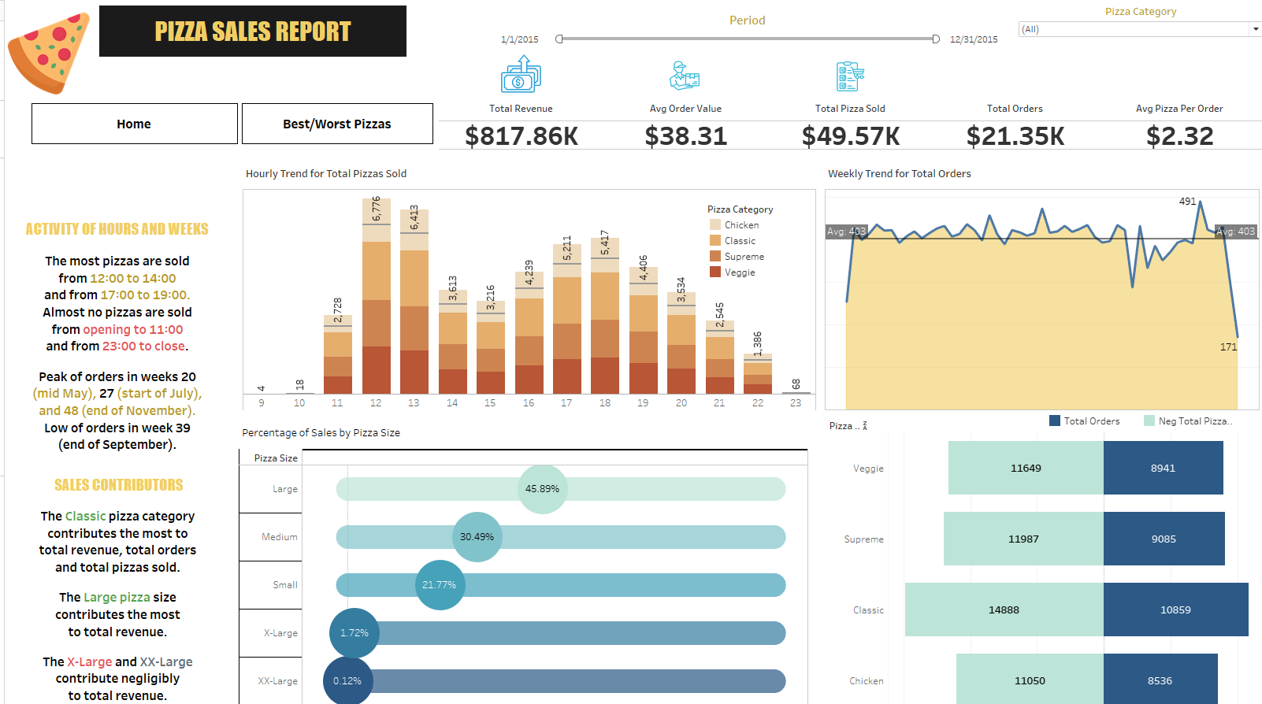

Best/Worst Pizza

